**sequences** are used to generate unique identifiers or numbers for records. These are commonly used for documents like invoices, sales orders, purchase orders, and custom models where unique numbering is required. Sequences ensure that identifiers follow a specified format and are generated in a predictable and consistent manner.

**Step 1: Define the Sequence in XML**

Create a new XML file (data/sequence_data.xml):

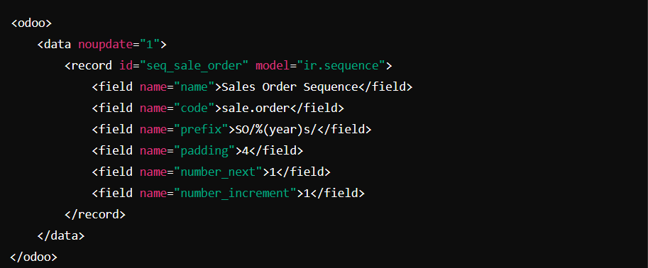

* **code** : Unique code to identify the sequence in the system
* **prefix** : Static text or variables (e.g., SO/ for sales orders).
* **padding :** The minimum number of digits in the sequence (e.g., 0001).

**Step 2: Load the XML File in Your Module**

Add this file to __manifest__.py inside the data list:

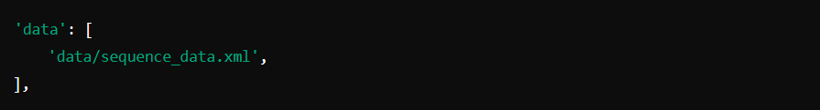

**Step 3: Use the Sequence in Your Model**

Modify your models/sale_order.py file:

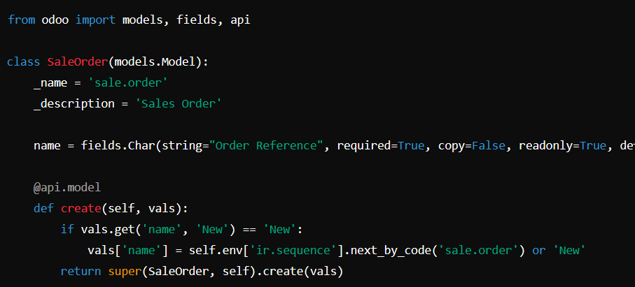

name = fields.Char(string="Name", required=True, copy=False, readonly=True, default='New')

* **next_by_code**: Fetches the next number from the sequence using its code.

**Step 4**: Field add in xml file

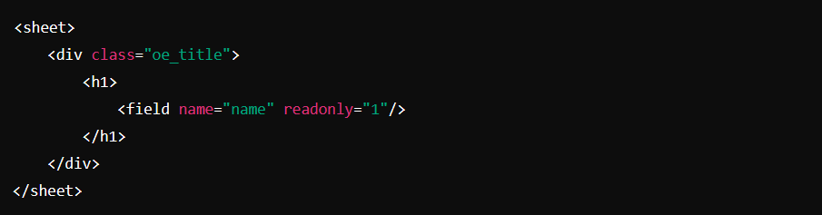

**Dynamic Prefixes & Suffixes**

Odoo allows you to use dynamic placeholders in the **prefix** and **suffix** fields of sequences to generate structured numbers based on variables.

**Commonly Used Variables**

| **Placeholder** | **Description** | **Example Output** |
| --- | --- | --- |
| %(year)s | Current year | 2025 |
| %(month)s | Current month | 02 (February) |
| %(day)s | Current day | 06 (6th of the month) |
| %(range)s | Date range defined in the sequence | 01 (if monthly reset) |
| %(company_id)s | ID of the company (useful in multi-company setups) | 1 (for Company 1) |
| %(user_id)s | ID of the user creating the record | 5 (if User ID is 5) |

**Company-Specific Purchase Order Sequence**

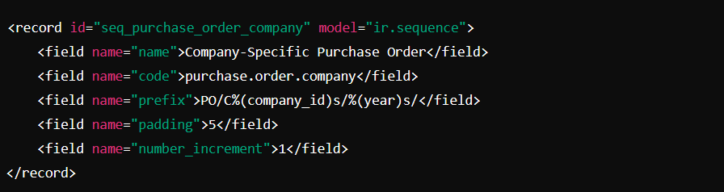✅ **Generated Number Example:** PO/C1/2025/00001

**Resetting Sequences Periodically Using use_date_range**

The **use_date_range** field allows a sequence to reset **annually, monthly, or daily**.

**Yearly Invoice Sequence**

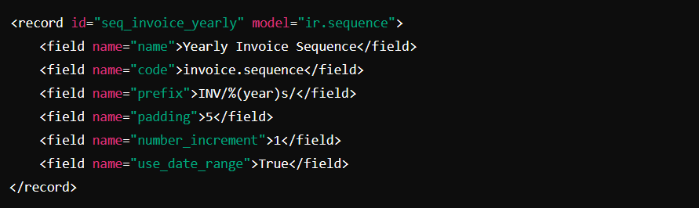✅ **Generated Number Example:** INV/2025/00001 (Resets every year)

**Monthly Resetting Sequence**

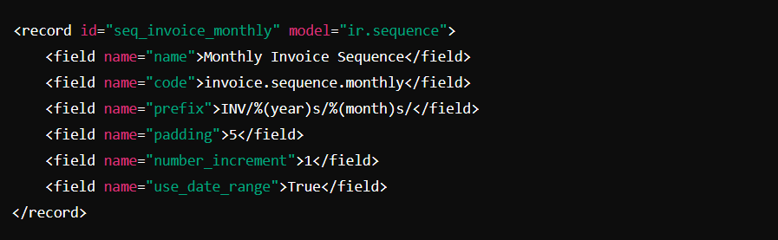✅ **Generated Number Example:** INV/2025/02/00001 (Resets every month)

**Key Concepts of Sequences in Odoo**

1. **Sequence Model:** Odoo manages sequences using the ir.sequence model.
2. **Numbering System:**
   * **Prefix**: Static text or dynamic variables (e.g., SO/2025/).
   * **Suffix**: Text appended after the number (e.g., /2025).
   * **Increment**: Defines the step value (default is 1).
   * **Padding**: Minimum number of digits in the sequence (e.g., 0001).
3. **Date Ranges:** Sequences can reset periodically (**daily, monthly, or yearly**).
4. **Multi-Company Support:** Sequences can be defined per company.